Logback

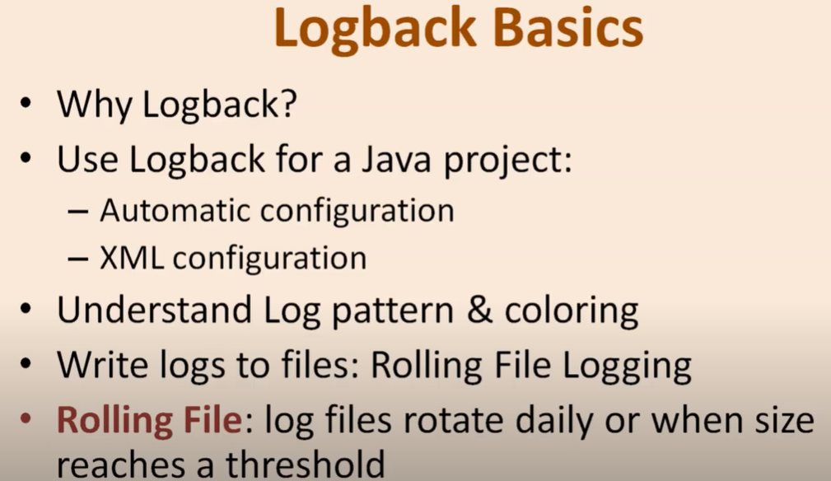 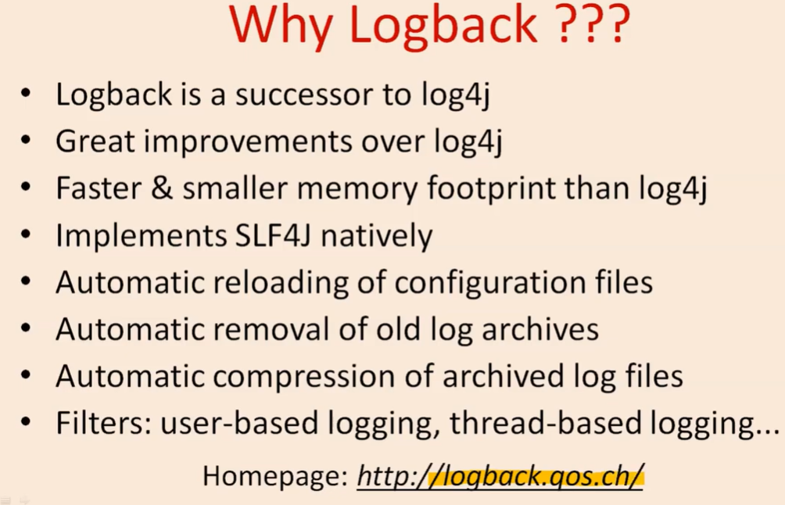

|  |  |
| --- | --- |
|  |  |

Create a file logback.xml

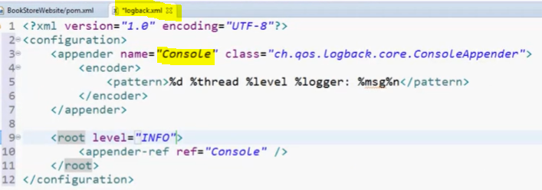

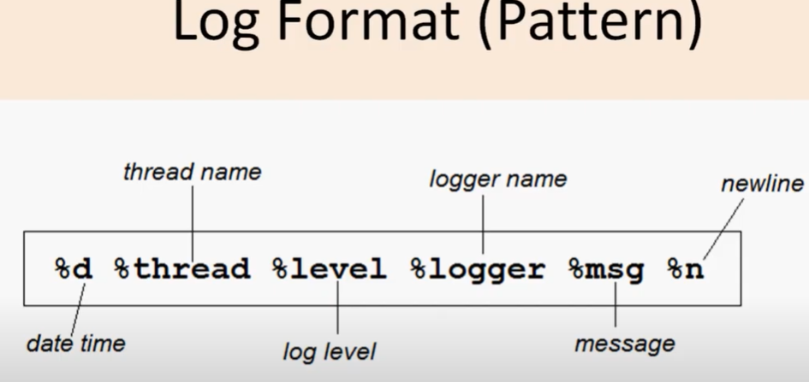

Here thread name is nothing but the class or method name which gets printed

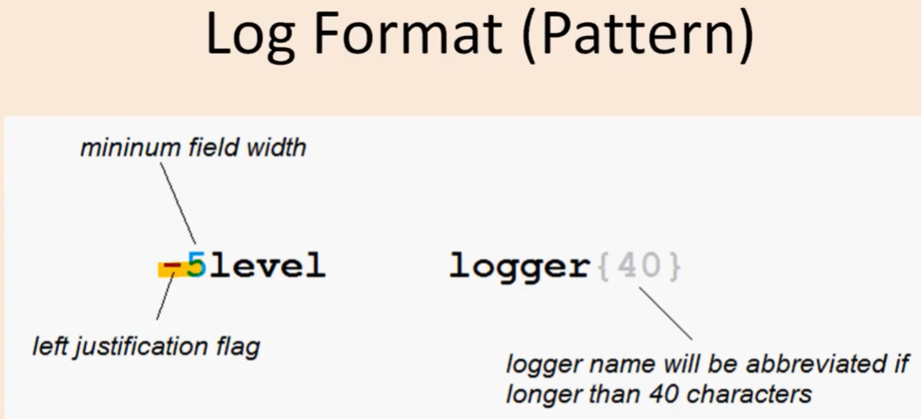

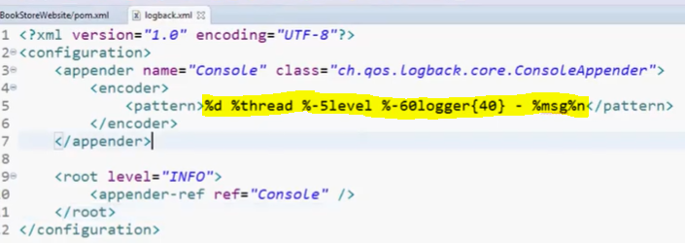

Or

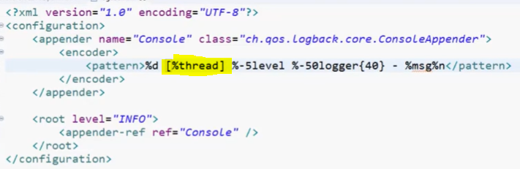





We have kept thread name inside [] and before message we have embadded [-] and same we can see in the console log.

Now in the class create logger to log the message like as given below.

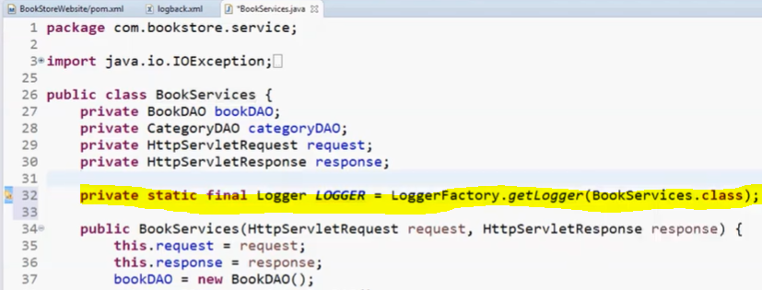

Since **logback** logger is built using slf4j so during creation of above marked line just import slf4 related classes here. Because it slf4 is just specification and in future if we want to switch to other logger then we we can easily switch between logging framework in future .

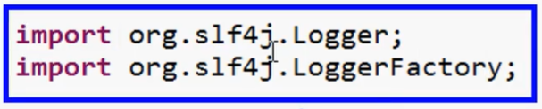

Now we can use different kind of log level as given in the below screen.

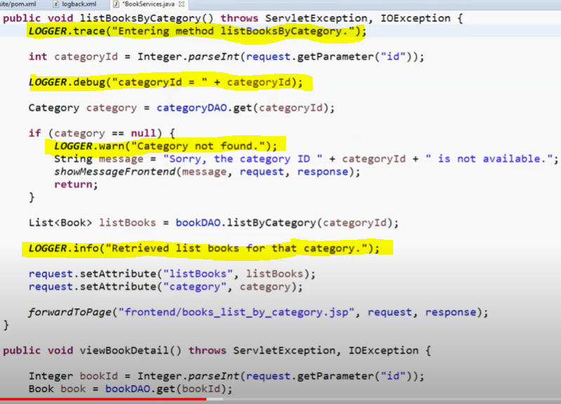

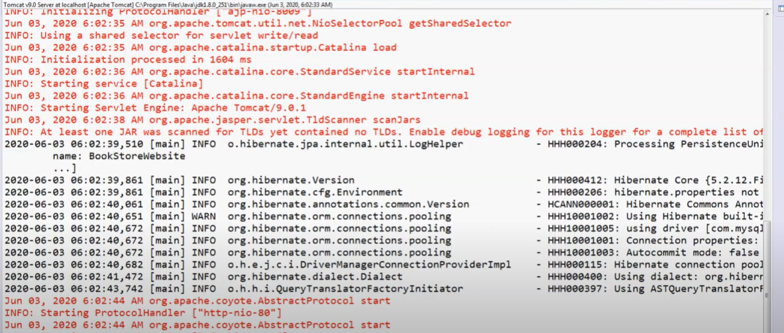

Black colour messages are coming from logback and red colour message are coming from tomcat.

**Defining the logger level for the particular package:**

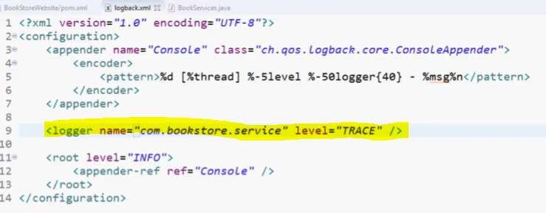



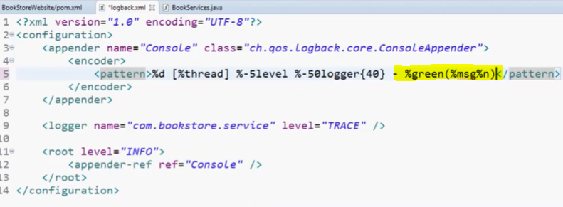

-green(%msg%n) : now all the message will start displaying in green in console.

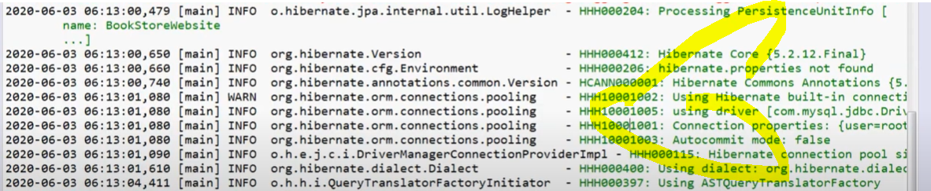

We can highlight log level in the log message by using below code.

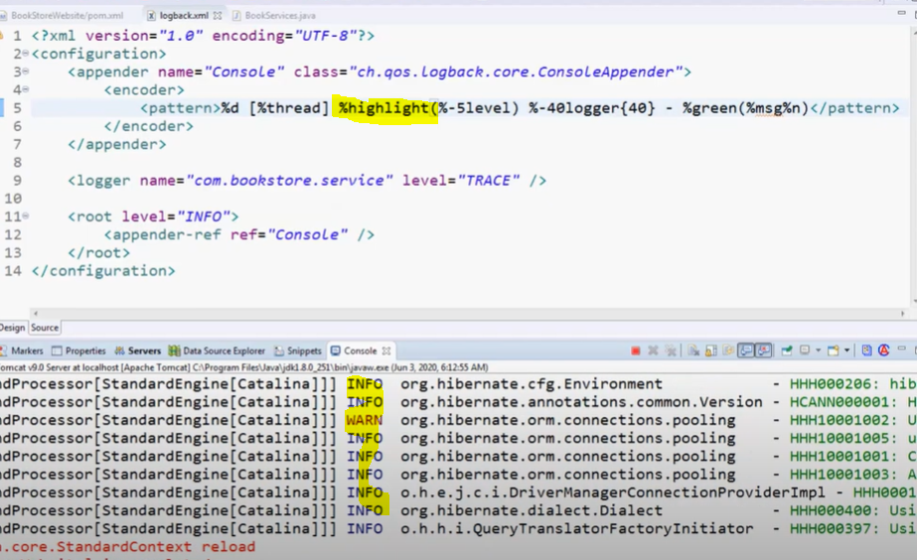



Now the log level start highlighting into different colours.

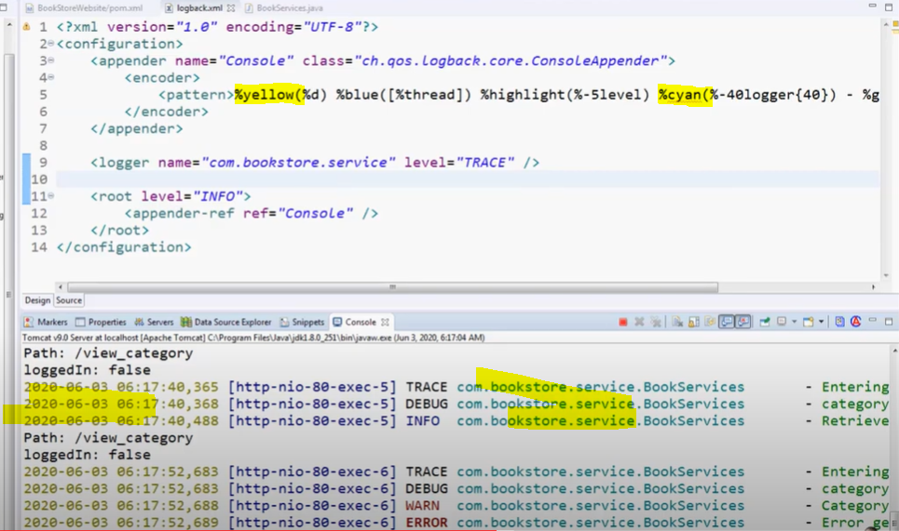

Change the date Time colour as yellow



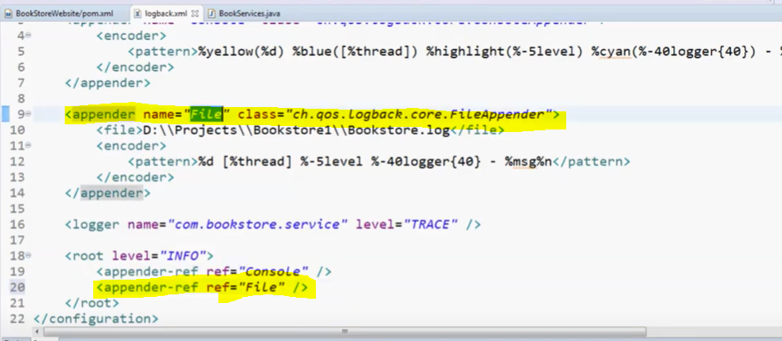

Now it will generate the log file with then name mentioned BookStore.log and and all the logs will be sotred in file as well .

So we have added all the configuration into <appender name =”File> ..</appender>

And second mention the appender name in the <appender-ref= “file>

**Now let’s add appender for rolling file logging based on day wise or when file reaches to its threshold size.**



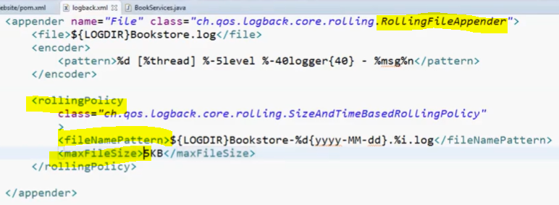

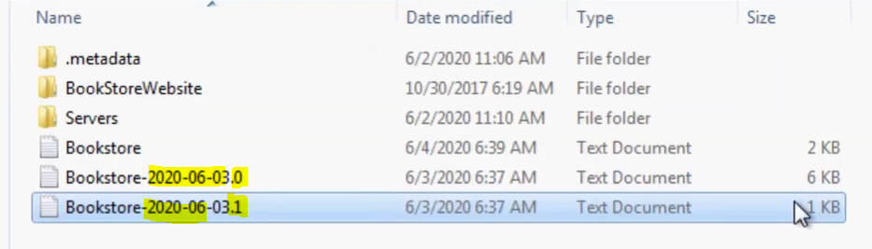

Log file is getting rolled everyday once the size threshold of the file got increased. And date and increment (0, 1, ..) getting appended.

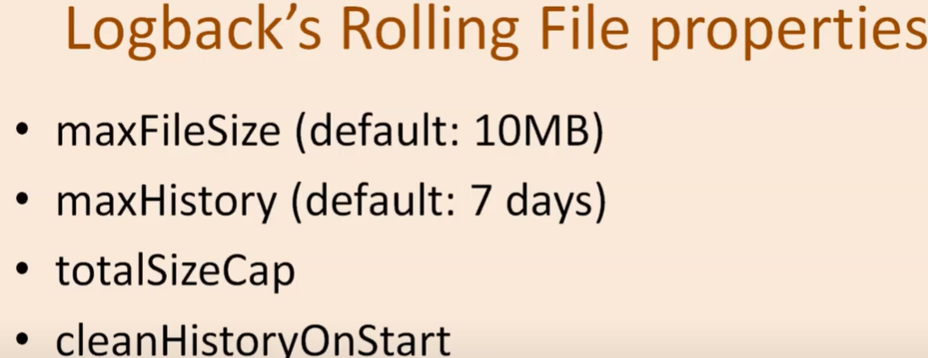

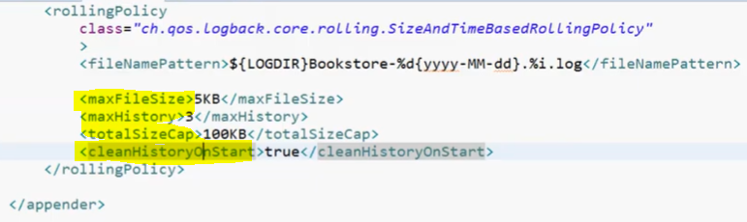

1. When MaxFile size become 5KB then generate another file based on the fileNamePattern
2. Delete the history after 3 days
3. Clean the history on start